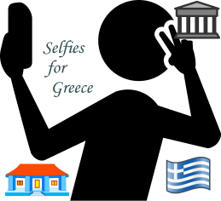

**Selfies for Greece**

**Questionnaire**

**Please give at least one answer to each question. Question 6 is optional.**

Question 1: Which are the most beautiful sights or monuments in your area?

1. …………………………………………………………………………………………………………………………………………………………..
2. …………………………………………………………………………………………………………………………………………………………..
3. …………………………………………………………………………………………………………………………………………………………..

Question 2: Which are the most important local buildings?

1. …………………………………………………………………………………………………………………………………………………………..
2. …………………………………………………………………………………………………………………………………………………………..
3. …………………………………………………………………………………………………………………………………………………………..

Question 3: Which outdoor activities are popular in your school?

1. …………………………………………………………………………………………………………………………………………………………..
2. …………………………………………………………………………………………………………………………………………………………..
3. …………………………………………………………………………………………………………………………………………………………..

Question 4: In your opinion, which are the most important locations in your hometown?

1. …………………………………………………………………………………………………………………………………………………………..
2. …………………………………………………………………………………………………………………………………………………………..
3. …………………………………………………………………………………………………………………………………………………………..

Question 5: Imagine that you want to send a photo to your friend who lives far away from you. Where would you like to take such a photo?

1. …………………………………………………………………………………………………………………………………………………………..
2. …………………………………………………………………………………………………………………………………………………………..
3. …………………………………………………………………………………………………………………………………………………………..

Question 6: Which local products are important for you?

1. …………………………………………………………………………………………………………………………………………………………..
2. …………………………………………………………………………………………………………………………………………………………..
3. …………………………………………………………………………………………………………………………………………………………..