**Grammar Activity 2**

**After having watched the video “Look up from your phone” twice, write about 5 things that would have been different, if the boy hadn’t stopped the girl in the street. (Work in pairs).**

**If the boy hadn’t stopped the girl in the street,**

**1)………………………………………………………………………….**

**2)………………………………………………………………………….**

**3)………………………………………………………………………….**

**4)………………………………………………………………………….**

**5)………………………………………………………………………….**

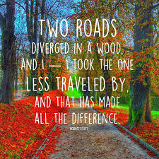

**Follow-up activity1: The above lines are from a well-known poem, by R. Frost. How are these lines related to the story of the boy and the girl you watched in the video? What do you think the word “roads” stands for? (Work in pairs).**

**Follow-up activity 2: Working in groups, can you come up with a verse using words you learned from the video? (It can be a rhymed one, or not).**