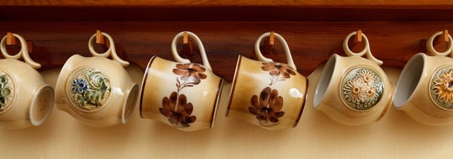

KEY FOR THE MATCHING ACTIVITY

You need beans, carrots, some onion and celery to make fasolada.

Put the beans in a bowl with water and leave overnight.

Boil the beans and drain.

Peel the carrots and cut the onions and celery.

Put oil in a pan, brown the onion and add all ingredients.

Add water and let boil all together for forty minutes.

Add tomato paste, salt and pepper.

Serve with lemon juice and enjoy!

