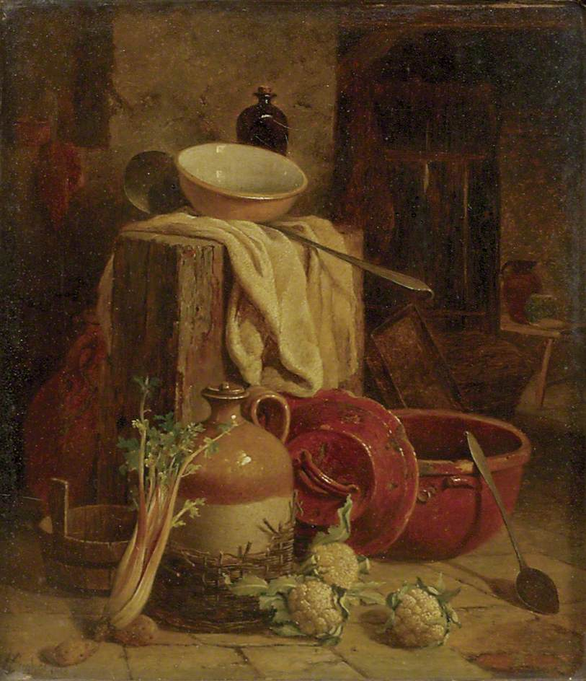
Read and match the halves below. Then put them in the appropriate order so that you have the whole recipe for the Greek beans soup.
Add tomato
some onion and celery to make fasolada.

Boil the beans
the onions and celery.

Put the beans in a bowl
Serve with lemon
Put oil in a pan, brown

all together for forty minutes.

paste, salt and pepper.

the onion and add all ingredients.

Peel the carrots and cut
and drain.

You need beans, carrots,
juice and enjoy!

Add water and let boil
with water and leave overnight.

