PREPARATORY WORKSHEET

Can you think of possible subtitles for the following 'Mr. Bean' screenshots?

A.

…............................................................................................................................................................................................................................................................................................................................................................................................................................................................................................................................................................................................................................................................

B.
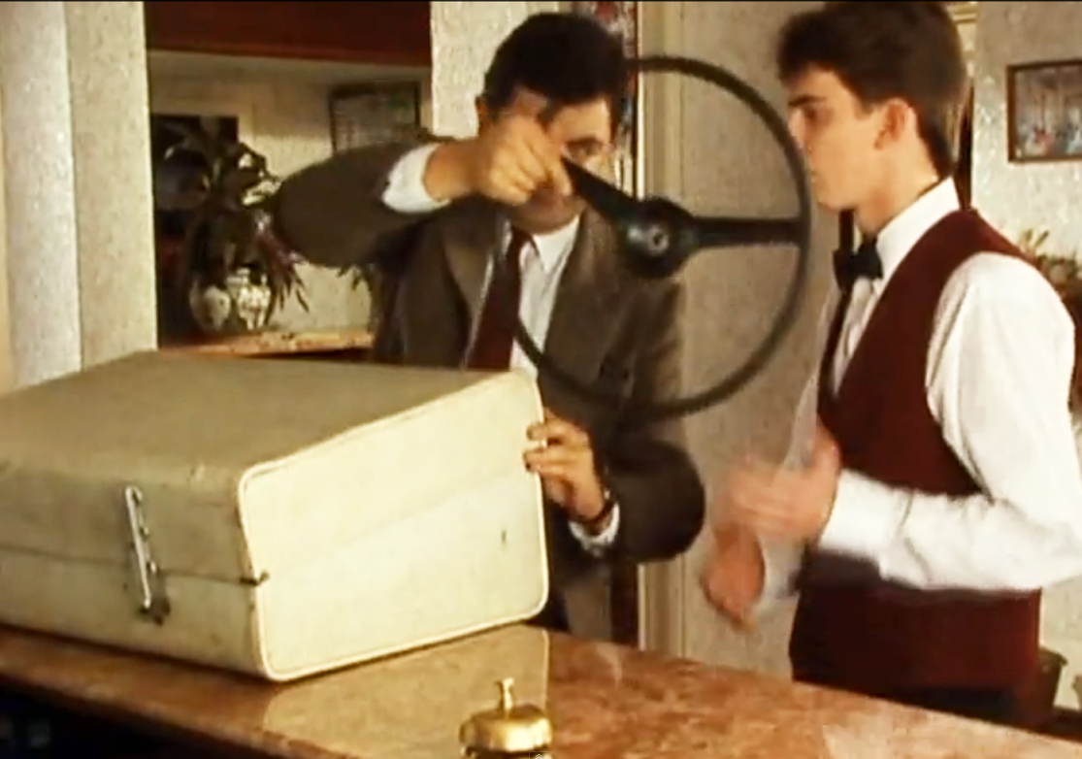

…...........................................................................................................................................................................................................................................................................................................................................................................................................................................................................................................................................................................................................................................................

C.

…............................................................................................................................................................................................................................................................................................................................................................................................................................................................................................................................................................................................................................................................

D.

…............................................................................................................................................................................................................................................................................................................................................................................................................................................................................................................................................................................................................................................................

