**Experiencing the American Culture and Identity Through the Rodeo**

**Student’s Worksheet – stage 1**

**Activities:**

1. **Look at the picture and try to answer orally to the following questions.**

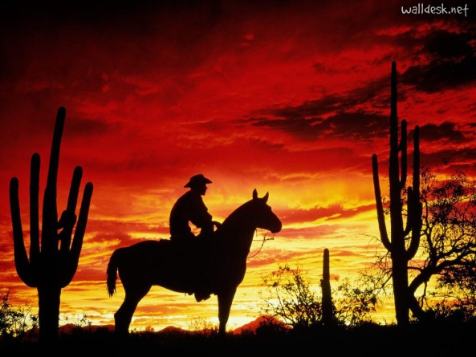

* What can you see in the picture?
* What do you know about cowboys?
* Where do they live?
* What could be their role in their society?
* How do you think this person feels in this picture?
* Could a woman have a similar role?