Experiencing the American Culture and Identity Through the Rodeo

Student’s Worksheet – stage 3
Choose the correct title for each Rodeo event from the list given.

Rodeo events:
- Barrel racing
- Bull riding
- Team roping
- Calf roping
- Steer wrestling

Rodeo event | Title
1) 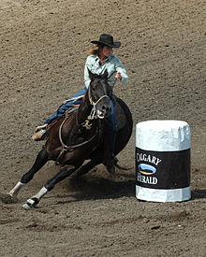 | ___________________
2)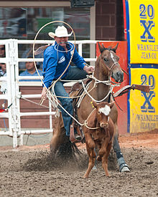 | ___________________
3)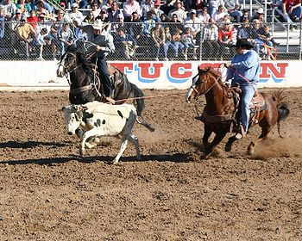 | ___________________
4) 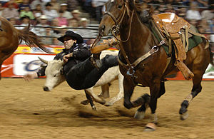 | ___________________
5)   

