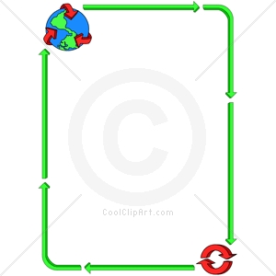**SAVE THE PLANET WORKSHEET 1**

**Task :**

**Decide in pairs or groups and write down the most important environmental problem(s) in the place where you live**

**(area, town, city, village).**

In our opinion one of the most important problems____________________________________________________________________________

_____________________________________________________________________________________________________________________________

_____________________________________________________________________________________________________________________________

_____________________________________________________________________________________________________________________________

_____________________________________________________________________________________________________________________________

_____________________________________________________________________________________________________________________________