**Step 2: Immigration word cloud**

You are divided in 5 groups. Look at the word cloud which contains useful immigration vocabulary. By the end of this activity you should all know the meaning of all the words in the cloud. In case you do not know the meaning of a word, look it up in the online dictionary (<http://dictionary.reference.com/>).

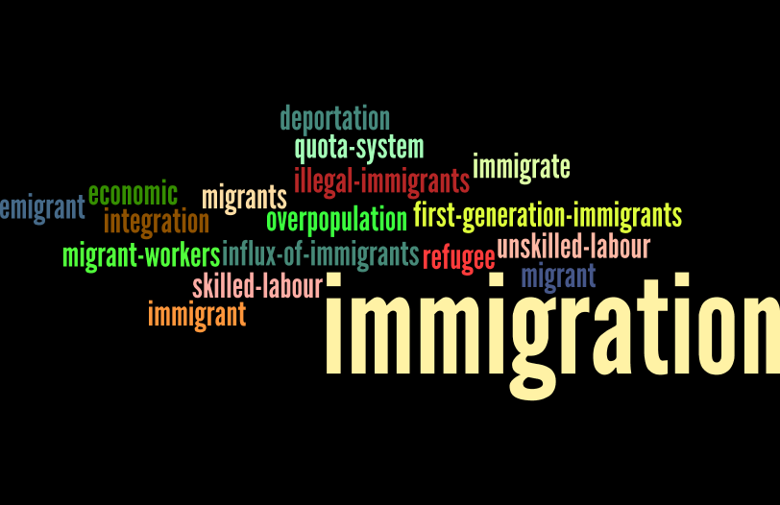

**Step 3: Prezi presentation**

Each group is given a graph or a flow chart, showing statistical data on the topic of immigration. Discuss your graphs in your groups and decide on the most interesting fact coming out from them. Help your teacher enter your information in the prezi presentation she has prepared for that reason. When you finish, you can enjoy the results of your group work!

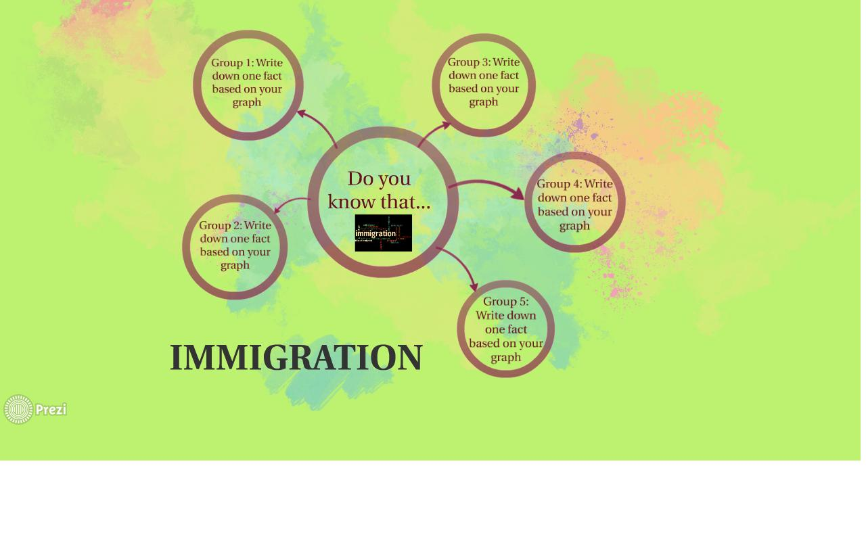The prezi presentation looks like this: