**In Class or Homework**

**Reading**

*Read the following descriptions and match them with the seven wonders of the ancient world. There is one extra item. Use the map on the next page showing their location to help you.*

*The Hanging Gardens of Babylon, Statue of Zeus, Temple of Artemis, Colossus of Rhodes, Lighthouse of Alexandria, Great Pyramid of Giza, Parthenon, Mausoleum at Halicarnassus.*

**Location: Egypt  
Built: About 2600 B.C.**The massive tomb of an Egyptian pharaoh, this is the only ancient wonders still standing today.  
  
**Location: Iraq  
Built: About 600 B.C.**Legend has it that this garden paradise was planted on an artificial mountain, but many experts say it never really existed.

**Location: Turkey  
Built: Sixth century B.C.**This towering temple was built to honor the Greek goddess of the hunt.

**Location: Greece  
Built: Fifth century B.C.**This 40-foot (12-meter) statue depicted a Greek god.  
  
**Location: Turkey  
Build: Fourth century B.C.**This elaborate tomb was built for a King.  
  
**Location: Greece  
Built: Fourth century B.C.**A 110-foot (33.5-meter) statue honored the Greek sun god Helios.  
 **Location: Egypt  
Built: Third century B.C.**This building used mirrors to reflect sunlight for miles out to sea.

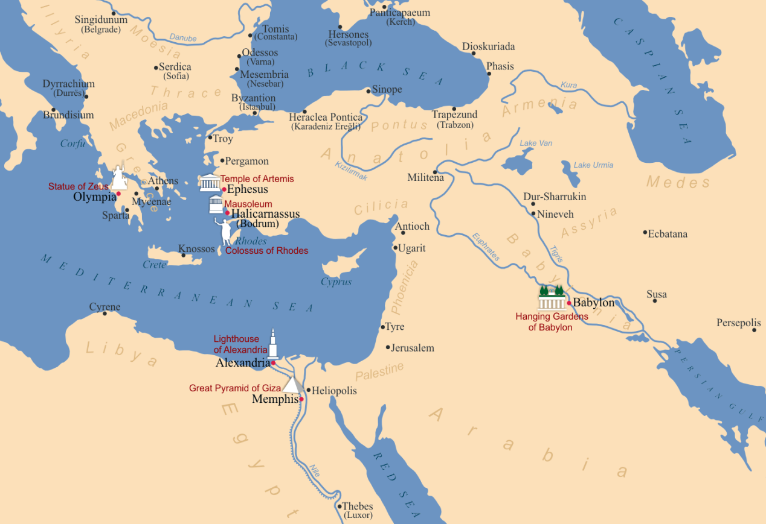

*From Wikipedia “Seven Wonders of the Ancient World”* [*https://en.wikipedia.org/wiki/Seven_Wonders_of_the_Ancient_World#/media/File:Seven_Wonders_of_the_Ancient_World.png*](https://en.wikipedia.org/wiki/Seven_Wonders_of_the_Ancient_World#/media/File:Seven_Wonders_of_the_Ancient_World.png)